|  |  |
| --- | --- |
| **FUNCTIONAL APPROVAL SHEET** | |
| Client Name | PT Astra International Tbk |
| Application Name | Mobile FS – Dashboard CMS |
| Function Name | Dashboard – CMS Mobile FS |
| Menu in Application | News/Alert |
| Version | 1.0 |

# Main Success Scenario: News/Alert

1. **Introduction**
2. This is a new submenu in version v.1.0.
3. This page can be accessed by Admin (Area Leader).
4. This page is used to broadcast (spread) News/Alert to all Mobile FS users or certain groups.
5. **Navigate to Form**
6. To load this form, User must access ‘(link CMS)’, log in to the application, then select ’News/Alert’ as shown below:

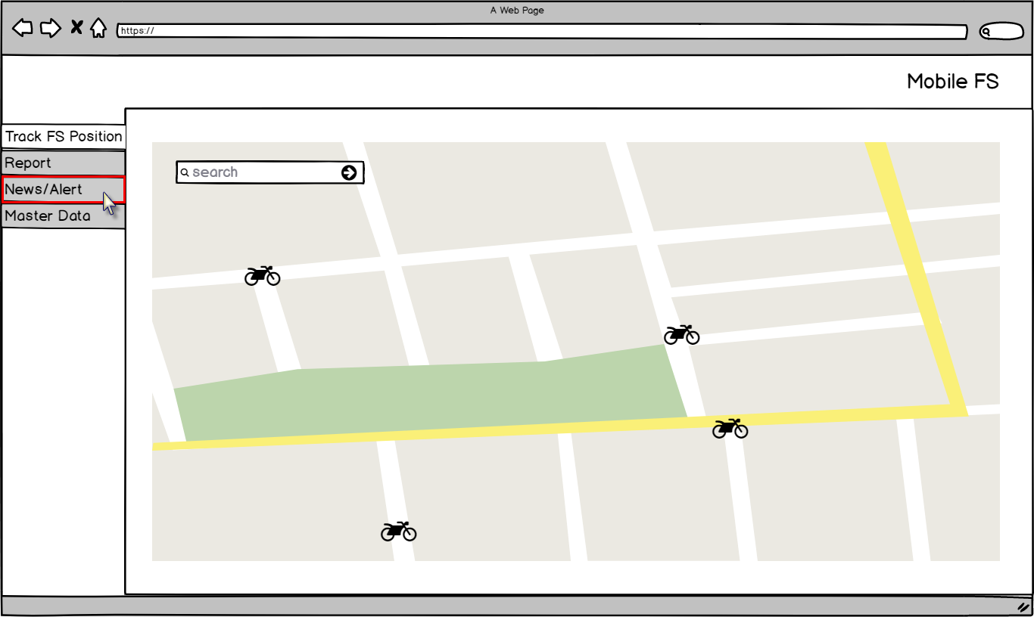

Figure – Navigation to ‘News/Alert’ – Mobile FS

1. Application will load following page:

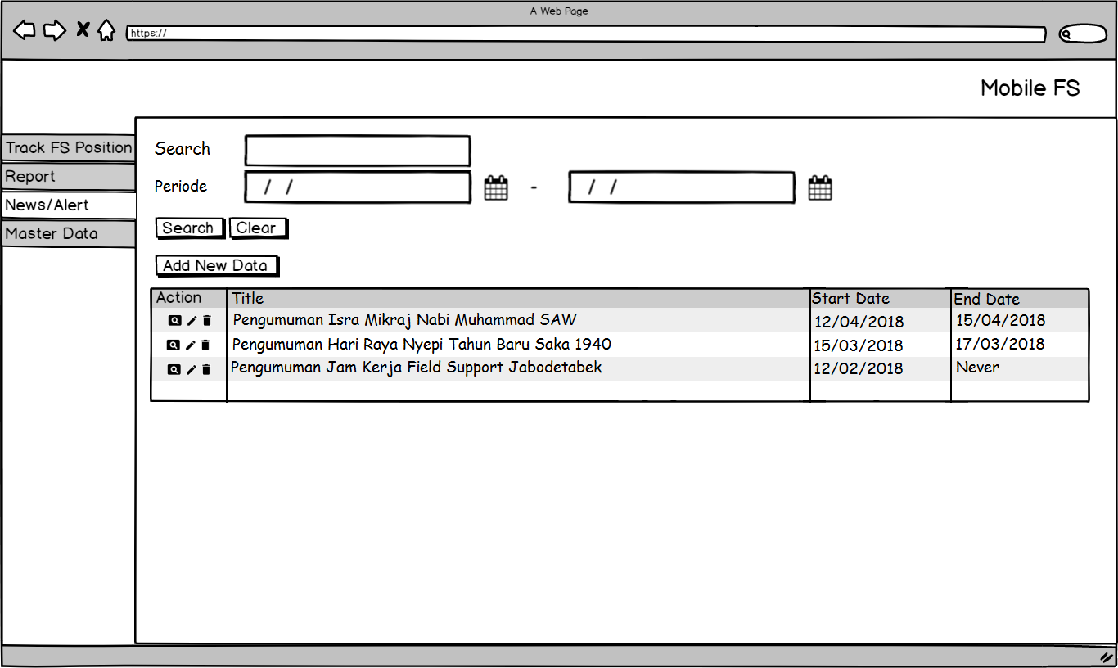

Figure – ‘News/Alert’ Page – Mobile FS

**Condition [Figure 2]:**

* Data displayed in News/Alert data grid are data where IsDeleted = 0 and taken from following tables and columns:

|  |  |  |
| --- | --- | --- |
| **COLUMN IN DATA GRID** | **TABLE IN DATABASE** | **COLUMN IN DATABASE** |
| Title | Alert | Title |
| Start Date | StartDate |
| End Date | EndDate |

* When initially loaded, application will enable following attributes:
* ‘Search’ text field.
* ‘Start Date’ date picker.
* ‘End Date’ date picker.
* ‘Search’ button.
* ‘Clear’ button.
* ‘Add New Data’ button.
* Application will disable data grid.
* Admin can sort data grid by ascending or descending, by clicking the header of the data grid. If Admin did not sort the data, data will be displayed based on last updated data.
* Admin can search News/Alert by typing the news title on ‘Search’ text box then click ‘Search’ button. Application will display list of News/Alert(s) that contain the inputted news/alert title. Here is the example if Admin types ‘Jam Kerja’ (highlighted in yellow):

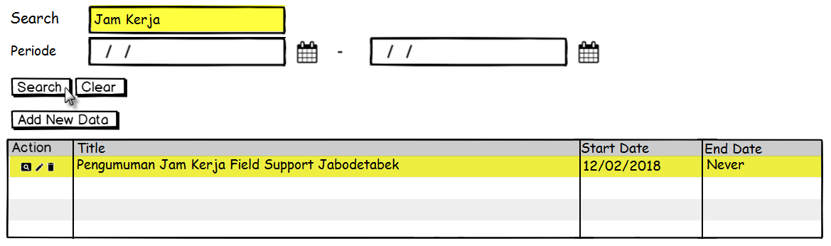

Figure – Example of Search Data – News/Alert

Admin can clear the value on ‘Search’ text box by clicking ‘Clear’ button, and then application will re-display the entire data.

1. **Function Provided in Form**

In this form, Admin can view, add, edit, and delete News/Alert as follow.

### View News/Alert

To view list of existing data, Admin must do following steps:

* 1. Log in to the application, then select ‘News/Alert’ as shown below:



Figure – Navigation to ‘News/Alert’ – Mobile FS

* 1. Then application will display list News/Alert in a following page as shown below:



Figure – ‘News/Alert’ Page – Mobile FS

* 1. Admin clicks ‘Detail’ button, then application will display detail of selected News/Alert as shown below:

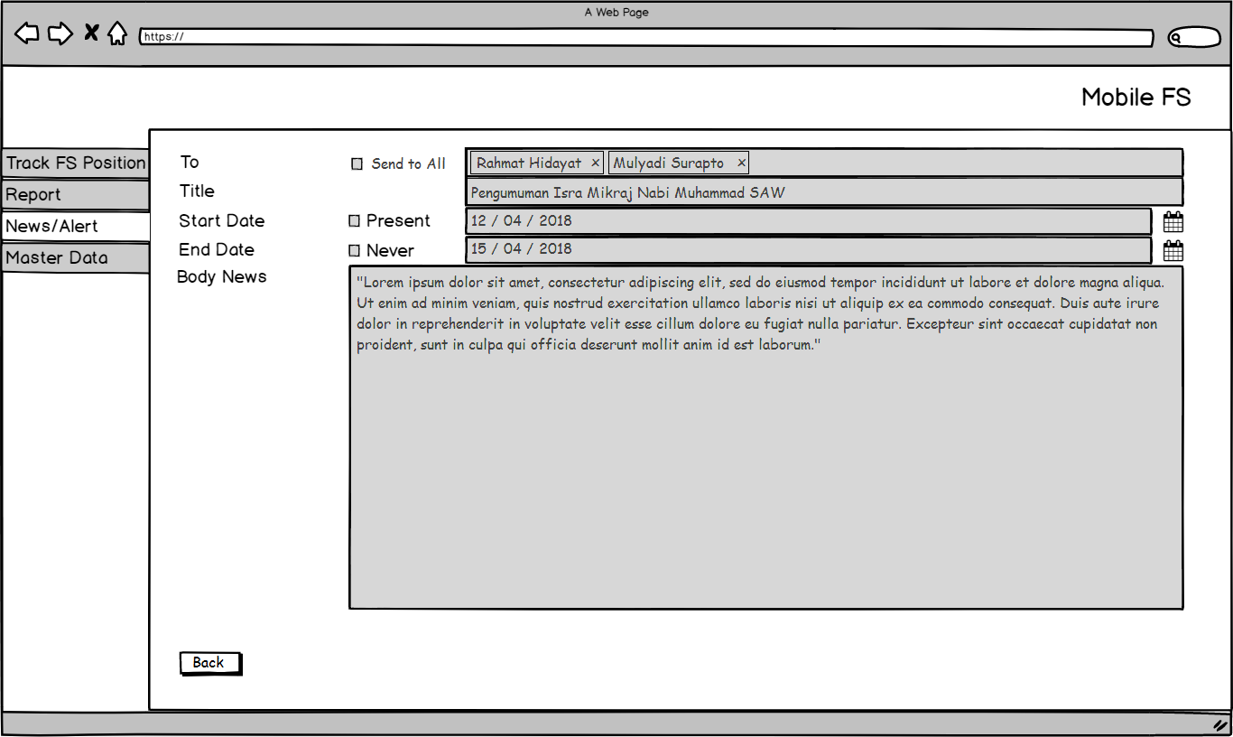

Figure – Detail News/Alert – News/Alert

**Condition [Figure 6]:**

* When initially loaded, application will enable following attributes:
* ‘Back’ button.
* Application will disable following attributes:
  + Send to All’ check box.
  + ‘To’ text field.
  + ‘Title’ text field.
  + ‘Present’ check box.
  + ‘Start Date’ date picker.
  + ‘Never’ check box.
  + ‘End Date’ date picker.
  + ‘Body News’ text area.

### Add News/Alert

To compose News/Alert, admin must do following steps:

* 1. Admin clicks ‘Add New Data’ button and application will display following page:

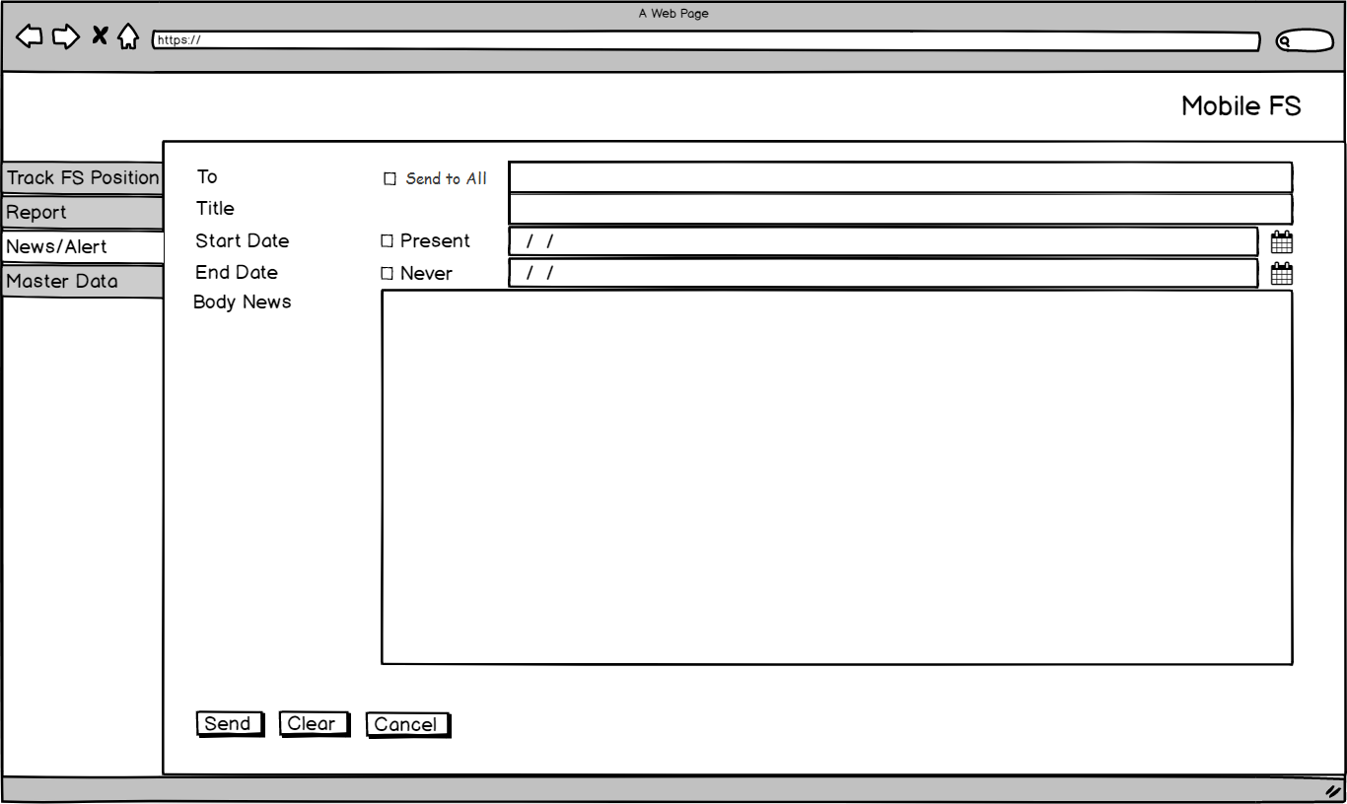

Figure – Compose News/Alert – News/Alert

**Condition [Figure 7]:**

In ‘Add New Data’ page, application will enable following attributes:

* ‘Send to All’ check box.
* ‘To’ text field.
* ‘Title’ text field.
* ‘Present’ check box.
* ‘Start Date’ date picker.
* ‘Never’ check box.
* ‘End Date’ date picker.
* ‘Body News’ text area.
* ‘Send’ button.
* ‘Clear’ button.
* ‘Cancel’ button.
  1. Admin has the option to tick or un-tick ‘Send to All’ check box as shown below:



Figure – ‘Send to All’ Checkbox – News/Alert

**Condition [Figure 8]:**

* This is not a mandatory field.
* If admin ticks the checks box, then the News/Alert will be sent to all users or groups.
  1. Admin can inputs the recipients’ name or group on ‘To’ text field to selects who will receive the News/Alert:



Figure – ‘To’ Text Field – News/Alert

**Condition [Figure 9]:**

* This is a mandatory field if ‘Send to All’ check box is not being ticked.
* Admin can type the user’s or group’s name, then application will display suggestions as shown below:

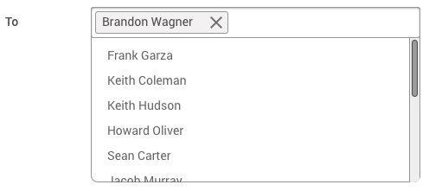

Figure – Display Suggested User/Group – News/Alert

**Condition [Figure 10]:**

* Admin selects the name based on the names that has been suggested.
* If admin wants to remove the recipient that has been selected, clicks on the ‘x’ sign as shown below:



Figure – ‘Close’ Button – News/Alert

* 1. Admin inputs the title of the News/Alert on ‘Title’ text field.



Figure – ‘Title’ Text Field – News/Alert

**Condition [Figure 12]:**

* This is a mandatory field.
* This field can be filled with alphanumeric.
  1. Admin has the option to tick or un-tick ‘Present’ check box as shown below:



Figure – ‘Start Date’ Checkbox – News/Alert

**Condition [Figure 13]:**

* This is not a mandatory field.
* If admin ticks the checks box, then the News/Alert will be displayed at present date and time.
  1. Admin can selects the start date of News/Alert on ‘Start Date’ date picker.



Figure – ‘Start Date’ Date Picker – News/Alert

**Condition [Figure 14]:**

* This is a mandatory field if ‘Present’ check box is not being ticked.
* Start date must be older than end date.
* The News/Alert will be displayed based on the start date and time that has been set by admin.
  1. Admin has the option to tick or un-tick ‘Never’ check box as shown below:



Figure – ‘End Date’ Checkbox – News/Alert

**Condition [Figure 15]:**

* This is not a mandatory field.
* If admin ticks the checks box, then the News/Alert will always be displayed on mobile FS application.
  1. Admin can selects the end date of News/Alert on ‘End Date’ date picker.



Figure – ‘End Date’ Date Picker – News/Alert

**Condition [Figure 16]:**

* This is a mandatory field if ‘Never’ check box is not being ticked.
* End date must be newer than start date.
* The News/Alert will not be displayed based on the end date and time that has been set by admin.
  1. Admin inputs the News/Alert message on ‘Body News’ text area.



Figure – ‘Body News’ Text Area – News/Alert

**Condition [Figure 17]:**

* This is a mandatory field.
* Can be filled with alphanumeric.
  1. Admin clicks ‘Send’ button, then application will apply following conditions:
     1. Check whether mandatory field has been filled.
     2. If the validation has passed successfully, then the inputted data will be inserted into table (Alert) in following columns:

|  |  |
| --- | --- |
| **COLUMN IN DATABASE** | **DESCRIPTION** |
| Id | Auto generated by system |
| RowStatus |  |
| AlertGroupId | Inputted recipients’ name or group who will receive the News/Alert. |
| Title | Inputted title of the News/Alert. |
| isStart | If Admin ticks the IsStart check box, then this column will be filled with ‘1’. Otherwise, this column will be filled with ‘0’. |
| StartDate | Inputted date when the News/Alert will be displayed (broadcasted) in mobile FS application. |
| isEnd | If Admin ticks the IsEnd check box, then this column will be filled with ‘1’. Otherwise, this column will be filled with ‘0’. |
| EndDate | Inputted date when the News/Alert will not be displayed (broadcasted) in mobile FS application. |
| Description | Inputted News/Alert content that will be sent to all users or certain group. |
| CreatedBy | Username who creates this data |
| CreatedOn | Date when data has been created |
| ModifiedBy | Empty / blank |
| ModifiedOn | Empty / blank |
| TimeStatus |  |

* 1. If Admin clicks ‘Clear’ button, then all the fields which have been filled or selected will be empty.

### Edit News/Alert

To edit existing data, Admin must do following steps:

* 1. Admin selects the News/Alert that want to be edited and clicks ‘Edit’ button, then application will display following page:

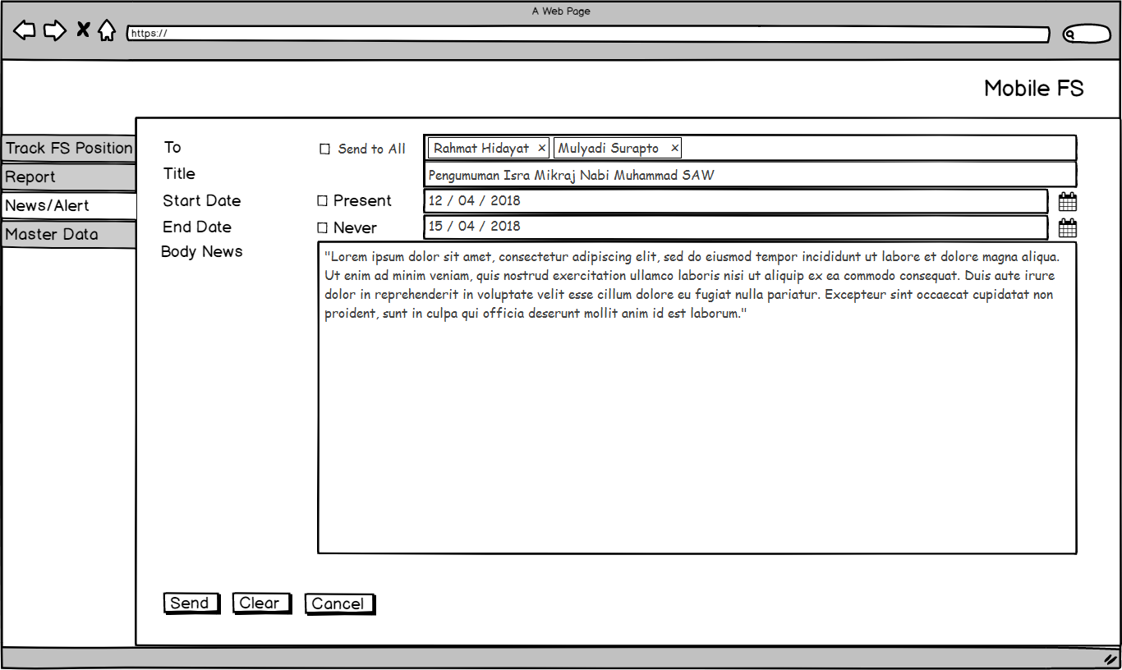

Figure – Edit News/Alert Form – News/Alert

**Condition [Figure 18]:**

While it is in ‘Edit News/Alert’ page, application will enable following attributes:

* ‘Send to All’ check box.
* ‘To’ text field.
* ‘Title’ text field.
* ‘Present’ check box.
* ‘Start Date’ date picker.
* ‘Never’ check box.
* ‘End Date’ date picker.
* ‘Body News’ text area.
* ‘Send’ button.
* ‘Clear’ button.
* ‘Cancel’ button.
  1. Admin has the option to tick or un-tick ‘Send to All’ check box as shown below:



Figure – ‘Send to All’ Checkbox – News/Alert

**Condition [Figure 19]:**

* This is not a mandatory field.
* If admin ticks the checks box, then the News/Alert will be sent to all users or groups.
  1. Admin edits the recipients’ name or group on ‘To’ text field to selects who will receive the News/Alert:



Figure – ‘To’ Text Field – News/Alert

**Condition [Figure 20]:**

* This is a mandatory field if ‘Send to All’ check box is not being ticked.
* Admin can type the user’s or group’s name, then application will display suggestions as shown below:



Figure – Display Suggested User/Group – News/Alert

**Condition [Figure 21]:**

* Admin selects the name based on the names that has been suggested.
* If admin wants to remove the recipient that has been selected, clicks on the ‘x’ sign as shown below:



Figure – ‘Close’ Button – News/Alert

* 1. Admin edits the title of the News/Alert on ‘Title’ text field:



Figure – ‘Title’ Text Field – News/Alert

**Condition [Figure 23]:**

* This is a mandatory field.
* Can be filled with alphanumeric.
  1. Admin has the option to tick or un-tick the ‘Present’ check box as shown below:



Figure – ‘Start Date’ Checkbox – News/Alert

**Condition [Figure 24]:**

* This is not a mandatory field.
* If admin ticks the checks box, then the News/Alert will be displayed at present date and time.
  1. Admin can edits the start date of the News/Alert on ‘Start Date’ date picker:



Figure – ‘Start Date’ Date Picker – News/Alert

**Condition [Figure 25]:**

* This is a mandatory field if ‘Present’ check box is not being ticked.
* Start date must be older than end date.
* The News/Alert will be displayed based on the start date and time that has been set by admin.
  1. Admin has the option to tick or un-tick the ‘Never’ check box as shown below:



Figure – ‘End Date’ Checkbox – News/Alert

**Condition [Figure 26]:**

* This is not a mandatory field.
* If admin ticks the checks box, then the News/Alert will always be displayed on mobile FS application.
  1. Admin can edits the end date of the News/Alert on ‘End Date’ date picker.



Figure – ‘End Date’ Date Picker – News/Alert

**Condition [Figure 27]:**

* This is a mandatory field if ‘Never’ check box is not being ticked.
* End date must be newer than start date.
* The News/Alert will not be displayed based on the end date and time that has been set by admin.
  1. Admin edits the News/Alert message on ‘Body News’ text area.



Figure – ‘Body News’ Text Area – News/Alert

**Condition [Figure 28]:**

* This is a mandatory field.
* Can be filled with alphanumeric.
  1. Admin clicks ‘Send’ button, then application will apply following conditions.
     1. Check whether mandatory field has been filled.
     2. If the validation has passed successfully, then the inputted data will be updated into table (Alert) in following columns:

|  |  |
| --- | --- |
| **COLUMN IN DATABASE** | **DESCRIPTION** |
| Id | Auto generated by system |
| RowStatus |  |
| AlertGroupId | Updated recipients’ name or group who will receive the News/Alert. |
| Title | Updated title of the News/Alert. |
| isStart | If Admin ticks the IsStart check box, then this column will be filled with ‘1’. Otherwise, this column will be filled with ‘0’. |
| StartDate | Updated date when the News/Alert will be displayed (broadcasted) in mobile FS application. |
| isEnd | If Admin ticks the IsEnd check box, then this column will be filled with ‘1’. Otherwise, this column will be filled with ‘0’. |
| EndDate | Updated date when the News/Alert will not be displayed (broadcasted) in mobile FS application. |
| Description | Updated News/Alert content that will be sent to all users or certain group. |
| CreatedBy | Username who creates this data |
| CreatedOn | Date when data has been created |
| ModifiedBy | Username who edited this data. |
| ModifiedOn | Date when data has been edited. |
| TimeStatus |  |

* + 1. Application will re-send the updated News/Alert to recipient(s).
  1. If Admin clicks ‘Clear’ button, then all the fields which have been filled or selected will be empty.

### Delete News/Alert

To delete data, Admin selects News/Alert that want to be deleted and clicks ‘Delete’ button, then application will display a confirmation message:

1. Admin clicks ‘Delete’ button in data grid, and application will display a pop up confirmation message as shown below:

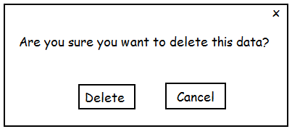

Figure – ‘Delete’ Confirmation Message – Master Data Feedback Options

* + 1. If Admin clicks ‘Delete’ button, then application will apply following conditions:
       1. Update the selected data IsDeleted = 0 into IsDeleted = 1.
       2. Remove the selected data from News/Alert data grid.
    2. If Admin clicks ‘Cancel’ button, then application will go back to previous page.

# Extension:

When ‘Search’ button is clicked in search News/Alert function:

1. If ‘Search’ text field is empty, following message will be shown:

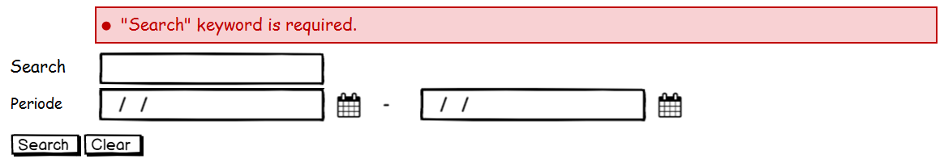

Figure – Error Message – News/Alert

When ‘Send’ Button is clicked in Compose New News/Alert Function:

1. If ‘To’ text field is empty, following message will be shown:



Figure – Error Message – News/Alert

1. If ‘Title’ text field is empty, following message will be shown:

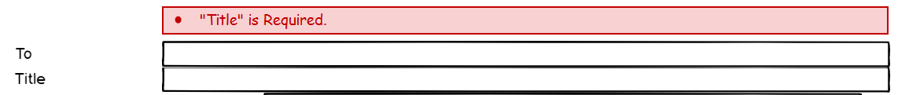

Figure – Error Message – News/Alert

1. If ‘Start Date’ is not selected, following message will be shown:

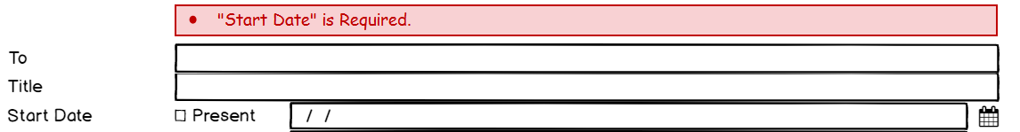

Figure – Error Message – News/Alert

1. If ‘End Date’ is not selected, following message will be shown:

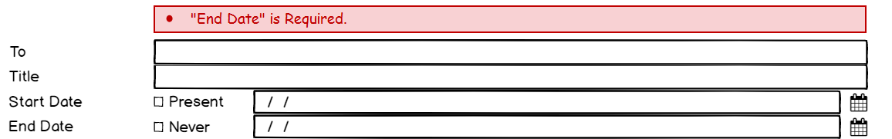

Figure – Error Message – News/Alert

1. If ‘Body News’ text area is empty, following message will be shown:

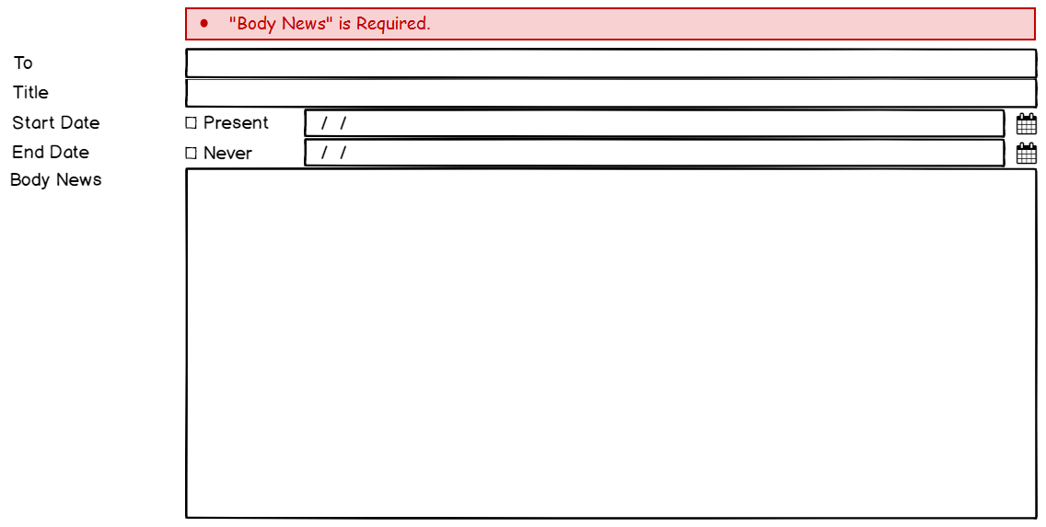

Figure – Error Message – News/Alert

|  |  |  |  |
| --- | --- | --- | --- |
| PREPARED BY | REVIEWED BY | | APPROVED BY |
|  |  |  |  |
| Name: Rizky Fitriandini | Name: Yongkie Saputra | Name: Rahmat Hidayat | Name: Arif |
| Moonlay Business Analyst | Moonlay Project Manager | Product Manager | Project Owner |
| Date: March 20th, 2018 | Date: April 10th, 2018 | Date: | Date: |

Copyright © Moonlay Technologies. All Rights Reserved.